Blue Team Shooting Sports Action Pistol November 11th, 2025
COURSE DESIGNER: Ike Starnes
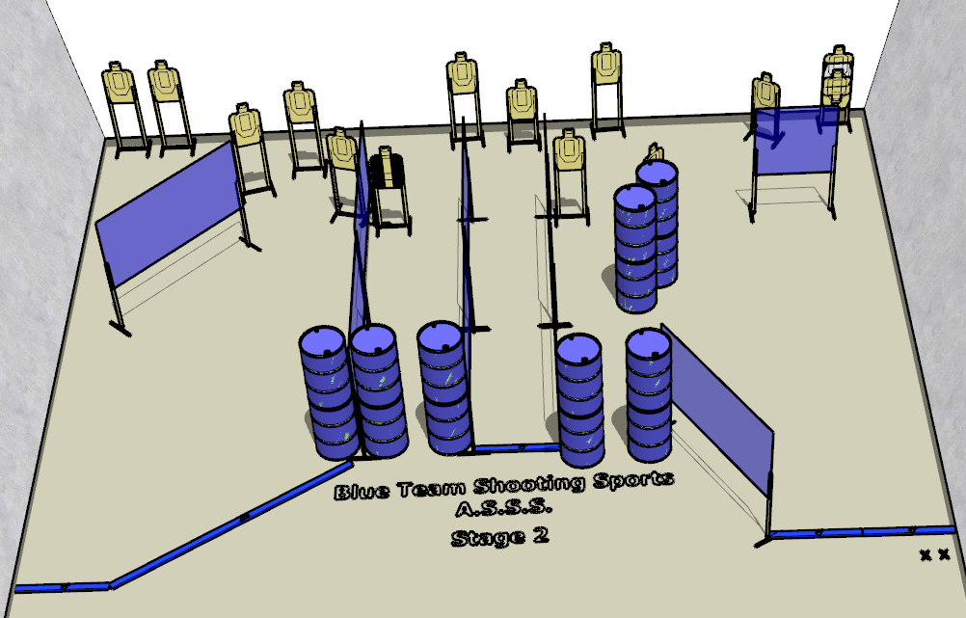

Written Stage Briefing:

Stage 2 - Fourteen Points - is a 28-round, 140 point, Comstock Course. There are 14 cardboard targets and some noshoots. The best 2 hits per cardboard target will be scored.
Handgun start position Both feet on Xs with wrists below belt. The handgun is loaded and holstered.
PCC start position Both feet on Xs. PCC is loaded with stock touching belt.
On the audible start signal, engage all targets from within the shooting area.

